**Viscommerce 3D Digital Twin photo – Personalization**

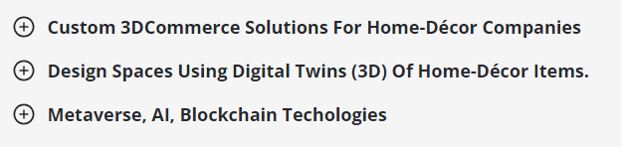

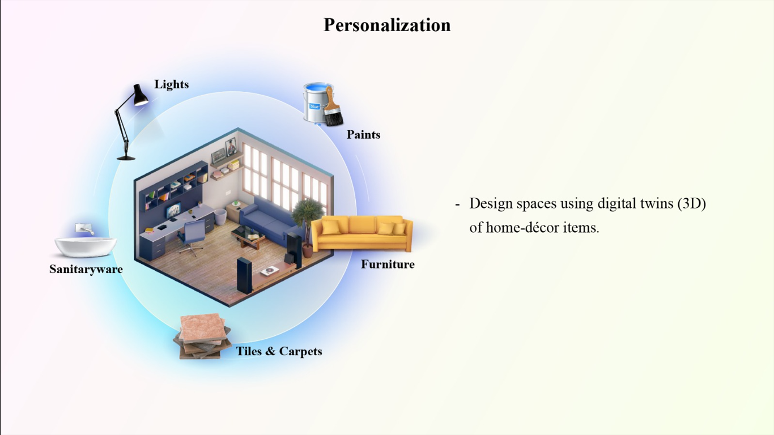

Subject: Elevating Retail and Living Experiences with VisCommerce Digital Twins

Dear [Recipient's Name],

I hope this email finds you well. I wanted to introduce you to an exciting development that has the potential to revolutionize the way we engage with both retail spaces and home environments – VisCommerce Digital Twins.

In today's fast-paced world, where online experiences are becoming increasingly immersive, VisCommerce Digital Twins offer a unique opportunity to bridge the gap between the physical and virtual realms. These 3D representations of stores and homes provide an interactive and dynamic platform that can transform the way we shop, design, and visualize spaces.

**For Retail:**

Imagine the possibilities of allowing your customers to virtually step inside your store from the comfort of their homes. VisCommerce Digital Twins enable an immersive shopping experience where customers can explore aisles, browse products, and even interact with virtual sales assistants. This technology not only enhances convenience but also helps create a memorable brand experience that can drive customer loyalty.

**For Home Environments:**

Whether you're an interior designer, real estate agent, or simply someone looking to reimagine your living space, VisCommerce Digital Twins offer a remarkable solution. These digital replicas allow you to visualize furniture arrangements, experiment with color schemes, and make informed decisions before committing to any changes. This technology empowers you to create spaces that perfectly align with your vision.

We have been actively exploring the potential of VisCommerce Digital Twins and have already witnessed the positive impact they can have on customer engagement and decision-making processes. Our team of experts is dedicated to tailoring this technology to meet your specific needs and objectives.

I would welcome the opportunity to discuss how VisCommerce Digital Twins can be integrated into your business strategy or personal projects.

Please let me know a convenient time for a brief call or meeting, and I'll be more than happy to provide a more in-depth overview and answer any questions you may have.

Thank you for your time, and I look forward to the possibility of collaborating on this innovative journey.

Best Regards,

Tanvi Gandhi